P R E S S R E L E A S E

New Record Figures for PI Technologies

Karlsruhe, Germany – April 22, 2024: In its annual survey of newly installed nodes, PROFIBUS & PROFINET International (PI) reports outstanding growth figures for its technologies. PROFIsafe and IO-Link in particular are showing impressive increases. Despite challenging market conditions, the other PI technologies also maintained their high growth rates.

The use of IO-Link in industrial plants is increasing significantly. An additional 15.9 million IO-Link devices were installed in 2023, which represents a record growth of 89 percent compared to the previous year (8.4 million devices). As a result, the total number of installed IO-Link nodes reached the substantial figure of 51.6 million by the end of 2023.

PROFIsafe continues on its road to success. A new milestone was reached in 2023 with an impressive 3.9 million nodes, which corresponds to an increase of 39 percent over the previous year (2022). This is the strongest annual growth ever seen in the history of PROFIsafe so far. The total number of PROFIsafe devices in the field now stands at 25.6 million, underscoring the continued relevance and reliability of this technology in applications where safety is critical.

Despite challenging market conditions, PROFINET was able to maintain its strong position as a leading technology in 2023. With a growth figure of 10.6 million nodes, PROFINET shows a high degree of stability, maintaining its record from the previous year (2022). This demonstrates the success and on-going demand for PROFINET in industrial applications. In total, an impressive 69.3 million PROFINET products have now been installed at many facilities over the years. For the first time, more PROFINET devices have been installed than PROFIBUS devices.

In 2023, PROFIBUS reached a stable growth figure of 1.5 million devices - the same as in the previous year. In process automation, the growth figure rose to 0.9 million, a moderate increase over the previous year, underscoring the demand for more data in process plants. A total of 68.9 million PROFIBUS devices were brought to the market, with 16.5 million of them having been installed at processing plants.

"The current figures reflect the clear trend towards more data and safety in industrial networks, but the effects of the component crisis and the build-up and reduction of inventories undoubtedly also played a role. PI is in an excellent position to drive innovation and development, laying the foundation for connected, efficient and future-oriented industry," said Xaver Schmidt, Chairman of PI (PROFIBUS & PROFINET International).

***

Graphic: For the first time, more PROFINET devices have been installed in the field than PROFIBUS devices.
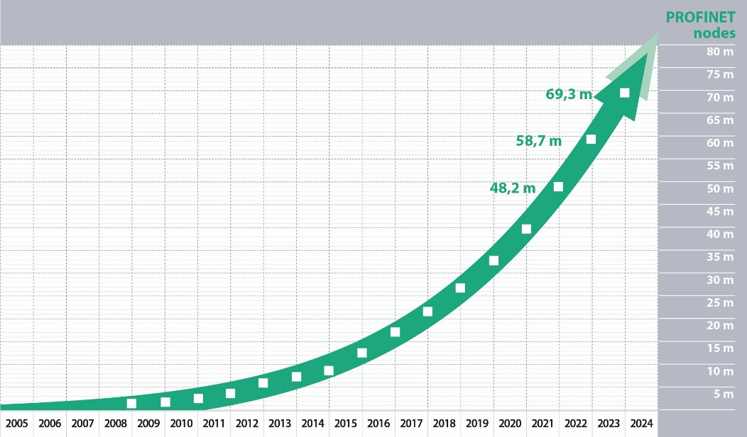

Graphic: The strong growth in IO-Link reflects the clear trend towards more data from the field level.
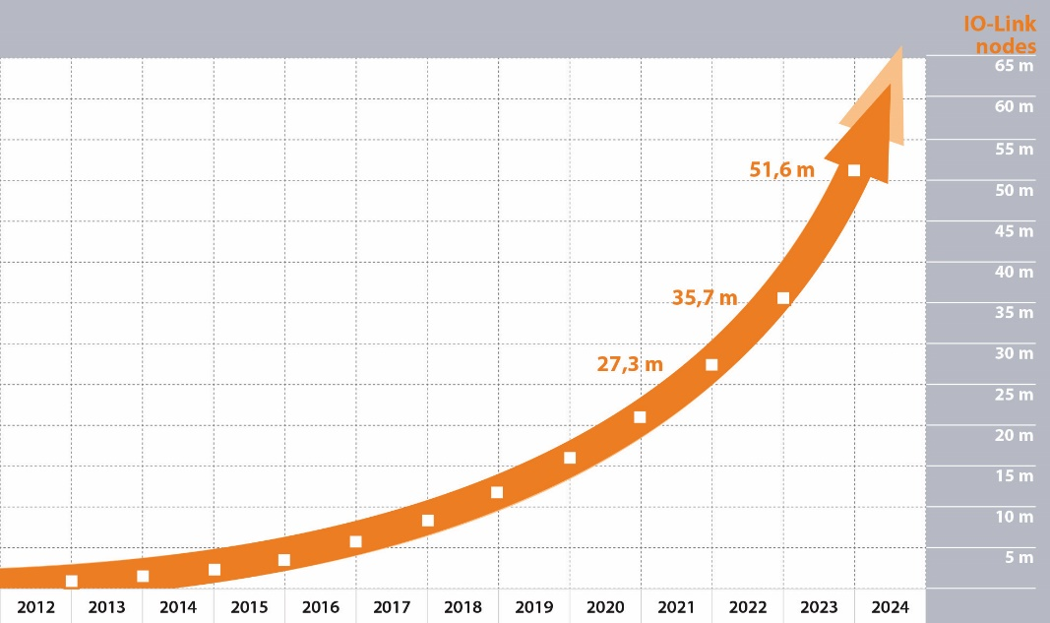

***

Press contact:
PI (PROFIBUS & PROFINET International)
PROFIBUS Nutzerorganisation e. V.
Barbara Weber

Ohiostr. 8

D-76149 Karlsruhe, Germany
Phone: +49 7 21/986 197 - 49
Barbara.Weber@profibus.com
http://www.profibus.com
The text of this press release is available for download at www.profibus.com.

